💧 高洁净 PET 水冷粉碎系统：生物医药企业
High-Purity PET Crushing System for Medical & Biotech Manufacturing —— 来自越都粉碎机的洁净制造解决方案,在生物医药和医疗器械制造行业

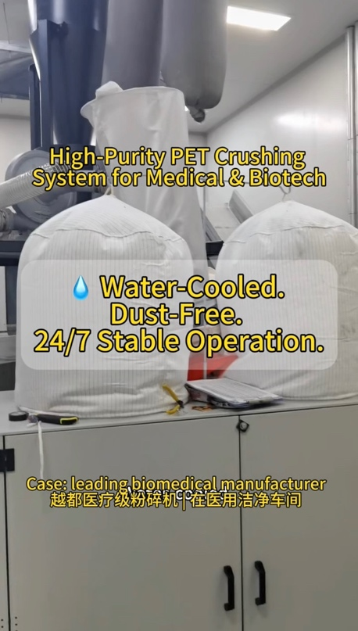 | 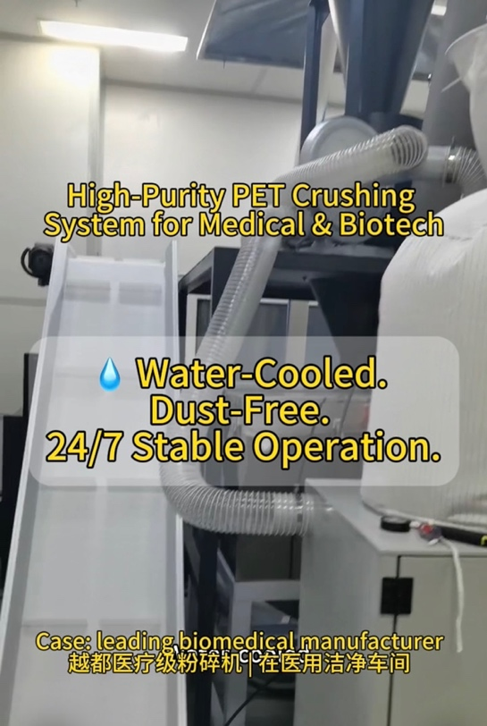 | 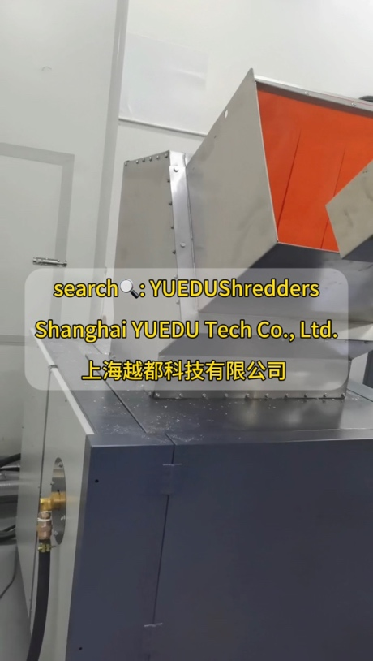

这是一家领先的生物医药企业， 专注于血液净化技术和医疗器械的研发制造。 他们的产品服务上千家医院， 是血液净化吸附领域最具创新力和研发深度的企业之一。
在他们的 PET 吹塑生产车间中， 五台自动吹塑机共用一台粉碎机， 用于回收和再利用生产中产生的 PET 料头。
而就是这一台看似普通的粉碎机， 长期以来却成了整个车间最让人头疼的设备。

⚙️ 问题从哪里来？
旧设备虽然是知名品牌、价格不菲， 但在连续运行时经常发热、粘料、堵网、停机； 粉尘外逸严重，污染了洁净环境； 刀具磨损快，几乎每月都要停机维护。
“最怕它出问题，五台主机都要跟着停。” 客户的生产主管这样说。
在医用包装行业， 一次设备停机，就可能导致几万只瓶坯报废， 更可能打乱整个生产计划。

于是，越都科技为他们设计了 一套专属的解决方案——
💧 SL4060 高洁净水冷粉碎系统。
这是一款专为生物医药与医疗耗材行业打造的粉碎机， 能够在医用级洁净环境中连续运行， 实现低温、低尘、高效、稳定的粉碎。

💡 关键技术
💧 循环水冷系统 — 双层冷却腔体结构，让箱体温度稳定在 25～30°C。 💨 双层防尘隔离 — 粉尘率低于 2%，出料洁净，可直接回收再造。 ⚙️ 高扭矩低速剪切系统 — 运行平稳、噪音低、能耗小。 🔄 负压抽料结构 — 下料顺畅不堵塞，产能提升 40% 以上。 🧱 全封闭外壳设计 — 符合洁净车间标准，防止二次污染。

项目落地后，效果立竿见影：
✅ 设备连续运行 24 小时不间断； ✅ 五条生产线同时运作，不卡机、不停机； ✅ 出料颗粒均匀、粉尘几乎为零； ✅ 车间温度更低，空气更清新，噪音更安静。
“以前我们天天清粉尘，现在一个星期都不用动。 工人都说，这台机终于能进洁净车间了。” —— 客户车间领班

这只是越都众多“洁净制造”解决方案中的一个缩影。
从医疗耗材到生物医药包装， 从自动化回收系统到整厂粉碎方案， 越都粉碎机（YUEDU Shredders） 始终以 Clean. Stable. Reliable. 为核心理念， 为客户打造更洁净、更安全、更高效的生产现场。
由上海越都科技自主设计与制造， 为全球生物医药与医疗器械行业 提供高标准的洁净生产保障。

#高洁净PET粉碎系统 #高洁净水冷粉碎系统 #PET粉碎机 #水冷粉碎机 #医疗级粉碎机 #医用洁净车间 #生物医药制造 #洁净生产 #PET粉碎系统

💧 High-Purity PET Crushing System for Medical & Biotech Manufacturing
— Clean. Stable. Reliable. Solutions from YUEDU Shredders

In the medical and biotechnology manufacturing industry,
“cleanliness” is not just a standard — it’s a matter of trust.
Inside every cleanroom,
airflow, temperature, dust particles, and even the sound of machines
can directly affect product safety and quality.
Today, let’s share a real story —
a story about clean manufacturing and trustworthy engineering.

🏥 The Client
A leading biomedical technology enterprise,
founded by overseas scientists,
specializing in blood purification systems and medical devices.
Their products are used in more than 1,000 hospitals nationwide,
and the company is recognized as one of the most innovative players
in the field of blood purification and precision medicine.
In their PET blow molding plant,
five automated production lines share a single crusher
to recycle PET bottle preforms and trimmings.
And yet, that small crusher became
the biggest headache in the entire workshop.

⚙️ The Problem
The previous machine — a well-known brand and quite expensive —
faced serious issues under continuous operation:
- Rapid heat buildup, causing PET to soften and stick to the screen.
- Frequent clogging and downtime during long production runs.
- Dust leakage, contaminating the cleanroom environment.
- Short blade lifespan, requiring frequent shutdowns for maintenance.
“Once it stops, all five lines stop with it.”
— Production Supervisor
In medical packaging,
a single unplanned stop could result in tens of thousands of rejected preforms
and disrupt the entire daily production schedule.

💡 The Challenge
The client’s request was simple:
“We just need a crusher that stays stable, stays clean, and doesn’t overheat.”
But in a GMP-grade cleanroom, achieving stability and cleanliness
is far from simple — it requires engineering precision.

🔧 The YUEDU Solution
YUEDU designed a tailor-made system for this facility:
The SL4060 High-Purity Water-Cooling PET Crushing System —
a machine built specifically for medical-grade PET recycling
and continuous operation in high-standard clean environments.
This new system combines advanced cooling, dust control, and low-noise engineering,
ensuring consistent performance and reliability 24/7.

🚀 Key Technical Highlights
💧 Closed-loop Water Cooling System –
Dual cooling chambers maintain internal temperature at 25–30 °C,
preventing PET softening and screen clogging.
💨 Dual Dust-Separation Layers –
Dust emission <2%; ultra-clean output suitable for direct reprocessing.
⚙️ High-Torque, Low-Speed Shear Design –
Smooth cutting, low vibration, reduced energy consumption.
🔄 Negative Pressure Extraction System –
Continuous suction keeps materials moving, boosts throughput by 40%.
🧱 Fully Sealed Enclosure –
Meets medical cleanroom standards and eliminates secondary pollution.

🌟 The Results
After installation, the improvements were immediate:
✅ Continuous 24-hour operation without overheating or downtime.
✅ Five production lines running simultaneously — stable and smooth.
✅ Output particles are uniform, dust-free, and ready for reuse.
✅ Workshop temperature decreased, noise levels reduced significantly.
“We used to clean dust every day.
Now we don’t need to touch it for a week.
This is the first crusher that truly belongs in a cleanroom.”
— Workshop Foreman

💰 Economic & Operational Impact
After adopting the YUEDU SL4060 system:
- Annual maintenance and downtime costs reduced by ~30,000 RMB.
- Production efficiency increased by 35%.
- Blade life extended threefold, cutting spare part expenses.
- Energy consumption reduced by nearly 40% compared to the old system.
Beyond cost savings, the biggest value is peace of mind.
No dust means no contamination risk.
No clogging means no production loss.
And less maintenance means more continuous productivity.

🌍 Why It Matters
This project represents more than a single upgrade —
it marks another step forward for clean and intelligent manufacturing
in China’s medical and biotech industries.
From medical consumables to pharmaceutical packaging,
YUEDU continues to deliver integrated,
energy-efficient, and clean shredding solutions
that empower global manufacturers to meet the highest standards.

🔷 Clean. Stable. Reliable.
💧 High-Purity PET Crushing System
for Medical & Biotech Manufacturing
Designed and built by Shanghai YUEDU Technology Co., Ltd.
We help medical and biotech manufacturers
achieve cleaner, safer, and smarter production environments —
one crushing system at a time.
YUEDU Shredders
Clean. Stable. Reliable. — Built for the Future of Clean Manufacturing.

#YUEDUShredders #PETCrusher #CleanroomManufacturing #BiotechIndustry
#MedicalPackaging #WaterCoolingSystem #SmartFactory #CleanProduction
#LowDustDesign #MadeInChina #SustainableManufacturing

🌐 Contact Us
Shanghai YUEDU Technology Co., Ltd.
📞 Contact Us to explore more customized models and tailored shredding solutions that suit your specific needs!
Let us help you find the perfect equipment for your application.
📱 Sales Supervisor: +86 159 0178 2779 (WhatsApp / WeChat / Facebook)
📱 Administrative Supervisor: +86 137 6138 5116
📧 Email: yuedushredders@gmail.com | denghao8410@gmail.com
🌐 Website: www.yuedushredders.com
@YUEDUShredders – Empowering Global Industries with Intelligent Destruction Systems.

